Exercise 3

- List all employees whose last names begin with P.
SELECT l_name FROM employee_data WHERE l_name LIKE 'P%';
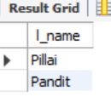
- Display the names of all employees in the marketing division.
SELECT f_name, l_name FROM employee_data WHERE title LIKE '%Marketing%';
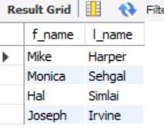
- What will the following statement display?
SELECT f_name, l_name, salary, from employee_data where f_name like ‘%k%’;
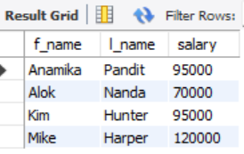
- List the last names and titles of all programmers.
SELECT l_name, title from employee_data where title like '%Programmer%';
